1. Write a (X)HTML program to create web page with forms, frames, links, image, marquee
Description :
Objective is to learn how to create a simple web page using html along with the forms, frames, links, image, marquee
HTML: Hyper Text Markup Language (HTML) is a mark up language developed by the W3C people. This can be used as an interface for working our programs. We submit all our requests in the HTML form. It is basically a markup language which describes how the documents are to be formatted. HTML has two basic entities, the “Tags” (Formatting commands) and the strings within the tags called as the “Directives”. Most of the tags have the following syntax: - <something> that indicates the beginning of the tag and a </something> that indicates the end of the tag
Procedure:-
1. Open a new file using Notepad.
2. Rename the file as page1.html (Extension for html programs is .html) which contain forms, frames, links, image, marquee
3. Use suitable tags wherever necessary.
Main.html
<html>
<head><title>Frames</title>
</head>
<frameset cols="50%,50%">
<frame src="form.html"/>
<frameset rows="16%,16%,16%">
<frame src="list.html"/>
<frame src="image.html"/>
<frame src="name.html"/>
</frameset>
</frameset>
</html>

Form.html
<html>
<head>
<title>Form</title>
</head>
<body>
<h1>Welcome to MCE</h1>
<form>
<p>Staff Name:<input type="text" size="30"></p>
<p>Staff Specialist Area:<input type="text" size="50"></p>
<p>Department</p>
<input type="radio" value="CS">CS
<input type="radio" value="EC">EC
<input type="radio" value="MECH">MECH
<input type="radio" value="IS">IS
<p>Experience</p>
<input type="check box" value="CS">above 10
<input type="check box" value="EC">>10</br>
<input type="reset" value="RESET">RESET
</form>
</body>
</html>
image.html
<html>
<head>
<title>img</title>
</head>
<body>
<img src="Screenshot.png">
</body>
list.html
<html>
<head>
<title>list of colleges</title>
</head>
<body>
<p> <marquee> <h2>LIST OF COLLEGES IN HASSAN</h2></marquee></p>
<ul><li>Malnad College Of Engineering</li>
<li>Rajeev</li>
<li>NDRK</li>
</ul>
<p><h2>LIST OF COLLEGES IN HASSAN</h2></p>
<ol><li>Malnad College Of Engineering</li>
<li>Rajeev</li>
<li>NDRK</li>
</ol>
<p><h2>LIST OF COLLEGES IN HASSAN</h2></p>
<dl><dt>MCE</dt><dd>Salagame Road</dd>
<dt>Rajeev</dt><dd>BM Road</dd>
<dt>NDRK</dt><dd>Ring Road</dd>
</dl>
</body>
</html>
name.html
<html>
<head>
<title>Fr</title>
</head>
<body>
<a href="table.html">table</a>
</body>
</html>

Output
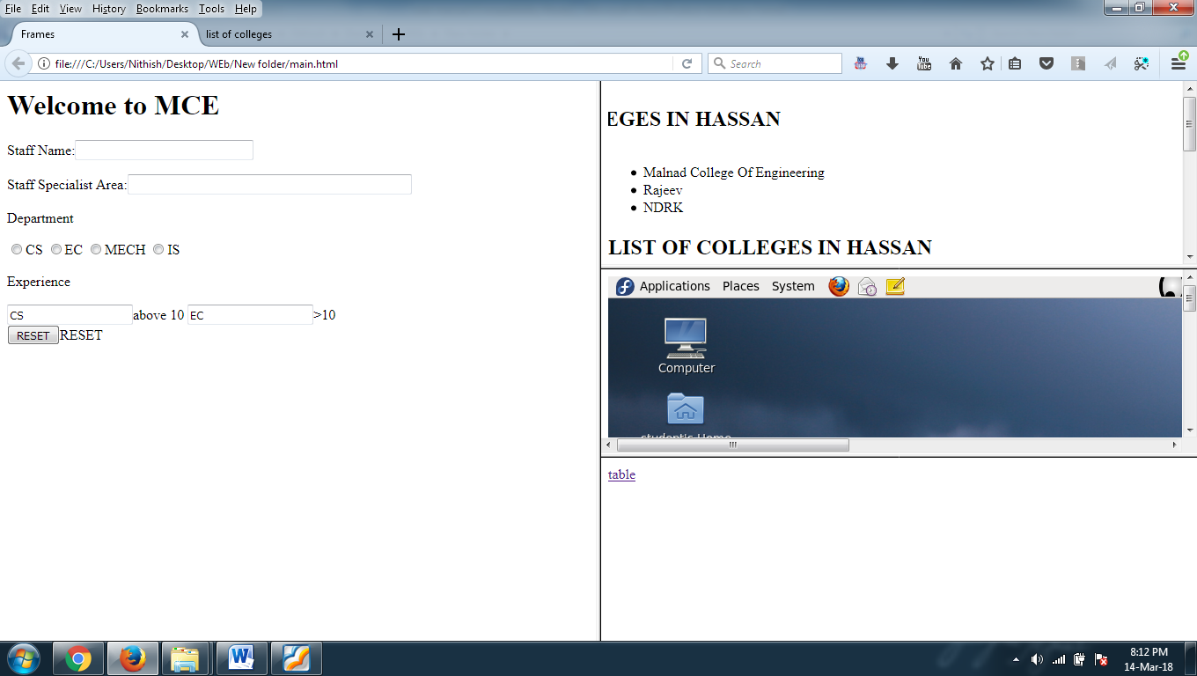

2. Develop and demonstrate a XHTML document that illustrates the use external style sheet, ordered list, table, borders, padding, color, and the <span> tag.
Description :
Objective is to learn how to create a simple web page using html along with the usage of style sheets, lists, creation or tables with borders, padding and colors.
HTML: Hyper Text Markup Language (HTML) is a mark up language developed by the W3C people. This can be used as an interface for working our programs. We submit all our requests in the HTML form. It is basically a markup language which describes how the documents are to be formatted. HTML has two basic entities, the “Tags” (Formatting commands) and the strings within the tags called as the “Directives”. Most of the tags have the following syntax: - <something> that indicates the beginning of the tag and a </something> that indicates the end of the tag.
CSS: Cascading Style Sheets (CSS) is a simple mechanism for adding style (e.g., fonts, colors, spacing) to Web documents. Using

Procedure:-
1. Open a new file using Notepad.
2. Rename the file as page1.html (Extension for html programs is .html)
3. Create a file (external cascading style sheet) by name Lab1.css where the font, size, colors etc.. are
specified. The style type should be set to “text/css” under the <head> tag.
4. The Lab1.css file should be included in page1.html file in the <link href ….> tag
5. In the <body> tag of the html document. Create an Ordered list using <ol> tag. Also create sublists
under the main list as shown below:
i. India
ii. Pakistan
iii. China
6. Create a Table which shows the India Japan and China and respective number of medals in Gold silver and bronze.
7. Fill the table using an appropriate colour and specify the thickness of the border for the table.
8. Use suitable tags wherever necessary.
___________________________________________________________________________
<?xml version="1.0" encoding="utf-8"?>
<!DOCTYPE html PUBLIC="-/W3C//DTD XHTML 1.1//EN"
http://www.w3.org/TR/xhtml 1.1/DTD/xhtml11.dtd>
<html xmlns="http://www.w3.org/1999</xhtml">
<head>
<title>program1</title>
<link rel="stylesheet" type="text/css" href="prg1.css" />
</head>
<body bgcolor="aqua">
<p>ordered list </p>
<ol>
<li>india</li>
<li>pakistan</li>
<li>china</li>
</ol>
<table cellspacing="6" cellpadding=”5” border="6">
<tr>
<th> </th>
<td style="color:green">GOLD</td>
<td style="color:red">SILVER</td>
<td style="color:blue">BRONZE</td>
</tr>
<tr>
<td style="color:green">INDIA</td>
<td>0</td>
<td>1</td>
<td>2</td>
</tr>
<tr>
<td style="color:yellow">CHINA</td>
<td>0</td>
<td>1</td>
<td>2</td>
</tr>
<tr>
<td style="color:red">JAPAN</td>
<td>1</td>
<td>0</td>
<td>2</td>
</table>
<p>
when we plan for <span class="spanred">
saving our hard earned money</span>,our focus is always to ensure that they are good.
</P>
</body>
</html>
Prg1.css
P{font-family:’Times New roman’;
font-size:10pt;
font-variant:normal;
font-style:italic;
font-weight:bolder;
text-decoration:underline;
text-indent:0.5in;
color:red;
}
.spanred {font size:16pt;
font-weight:ligher;
color:green; }

OUTPUT:
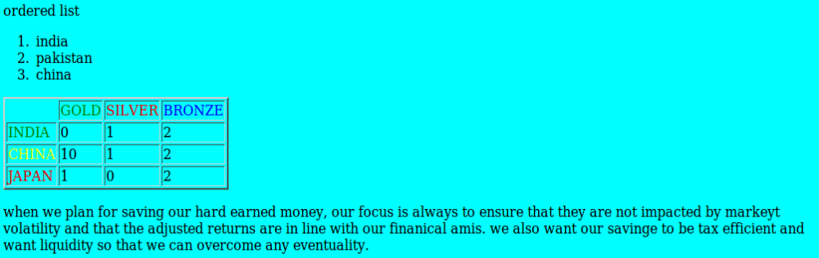

3. Create a JavaScript that prompts the user for a number and then counts from 1 to that number displaying only the odd numbers using alert window.

Description :-
Objective of this program is to get acquainted with javascript and how to use javascript in html code.

JavaScript (JS) is a dynamic computer programming language. It is most commonly used as part of web browsers, whose implementations allow client-side scripts to interact with the user, control the browser, communicate asynchronously, and alter the document content that is displayed. It is also being used in server-side network programming , game development and the creation of desktop and mobile applications.
JavaScript is written into an HTML document in 2 ways:
• Using: <script type="text/JavaScript"> Where you would embed your code here </script>
• Or referencing it kind

Procedure :-
1. Declare the script tag as text/JavaScript in the beginning of the <body> of html program
2. Get the number using prompt()
3. For the numbers from 1 to n, generate odd number
4.using alert display result.
________________________________________________________________________
<?xml version="1.0" encoding="utf-8"?>
<!DOCTYPE html PUBLIC "-//W3C//DTD XHTML 1.1//EN" "http://www.w3.org/TR/xhtml1/DTD/xhtml11.dtd">
<html xmlns="http://www.w3.org/1999/xhtml" xml:lang="en">
<head>
<title>Test</title>
</head>
<body>
<script type="text/javascript">
var count=0;
var msg ="Odd numbers are:\n"
var n=prompt("Enter a number ", " ");
for (i = 0; i < n; i++)
{
if ((i % 2) != 0)
{
count++;
msg=(msg+i+"\n");
}
}
alert(msg +"Number of odd numbers are"+count);
</script>
</body>
</html>

OUTPUT:
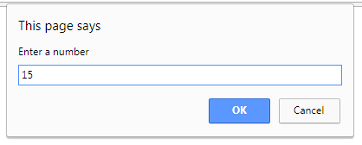

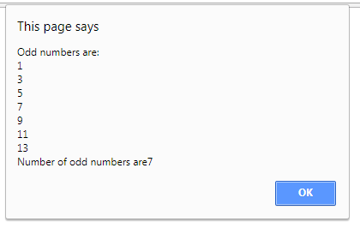
4. Write a java script to validate the following fields in a registration page
- Name (should contains alphabets and the length should not be less than 6 characters)
- Password(should not be less than 6 characters)
- E-mail(should not contain invalid addresses)

Main.html
<html >
<head>
<!--external javascript-->
<script typ="text/javascript" src="validation.js" >
</script>
</head>
<body>
<center>
<h1>Demo Registration Form</h1>
<form name="form1" method="post" action="success.html">
<table border='0'>
<tr>
<td><LABEL for="firstname">First Name:<sup style="color:#F00">*</sup> </LABEL></td>
<td><INPUT type="text" id="firstname"></td>
</tr>
<tr>
<td><LABEL for="lastname">Last Name:<sup style="color:#F00">*</sup> </LABEL></td>
<td><INPUT type="text" id="lastname"></td>
</tr>
<tr>
<td><LABEL for="email">Email:<sup style="color:red;">*</sup> </LABEL></td>
<td><INPUT type="text" id="email"></td>
</tr>
<tr>
<td></td><td><br/><INPUT type="submit" onClick="return validateForm()" value="Submit">
<INPUT type="reset" onClick="return confirmreset()"></td>
</tr>
<tr>
<td></td><td style="font-size:12px;text-align:right;"><br/><i style="color:red;font-size:12px;align:right;" >* - Mandatory</i></td>
</tr>
</table>
</FORM></center>
</body>
</html>
Validation.js
function validateForm()
{
var x=document.forms["form1"]["firstname"];
if (x.value=="")
{
alert("Please enter the First name.");
x.focus();
return false;
}
else if(x.value.length<6)
{
alert("First name cannot be greater than 6 characters.");
x.value="";
x.focus();
return false;
}
else if ((!namepattern.test(x.value)))
{
alert("First name should contain only alphabets.");
x.value="";
x.focus();
return false;
}
x=document.forms["form1"]["lastname"];
if(x.value=="")
{
alert("Please enter the Last name.");
x.focus();
return false;
}
else if(x.value.length>20)
{
alert("Last name cannot be greater than 20 characters.");
x.value="";
x.focus();
return false;
}
else if (!namepattern.test(x.value))
{
alert("Last name should contain only alphabets.");
x.value="";
x.focus();
return false;
}
x=document.form1.email;
if(!emailpattern.test(x.value))
{
alert("Invalid email id.");
x.value="";
x.focus();
return false;
}
if(confirm("Do you want to submit the form?"))
{
alert("Registration Form Submitted Successfully.");
}
else
return false;
}
function confirmreset()
{
return confirm("Do you want to reset the form?");
}
_______________________________________________________________________
OUTPUT:
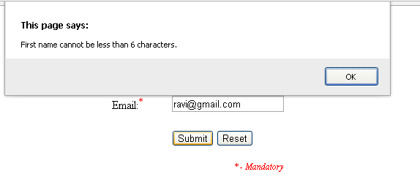

5. Develop and demonstrate, using JavaScript script, a XHTML document that collects the USN ( the valid format is: A digit from 1 to 4 followed by two upper-case characters followed by two digits followed by two upper-case characters followed by three digits; no embedded spaces allowed) of the user. Event handler must be included for the form element that collects this information to validate the input. Messages in the alert windows must be produced when errors are detected.
Description :
Objective is to write functions in html, validate using regular expressions.

HTML Functions are extremely useful, and they can save you from writing bunch of redundant code.
In html elements organized into groups according to function.

Regular expressions are patterns used to match character combinations in strings. In JavaScript, regular expressions are also objects. These patterns are used with the exec and test methods of RegExp, and with the match, replace,search, and split methods of String.

Proceedure :-

1. Declare the script tag as text/javascript in the beginning of the <body> of html program
2. Get the Roll No. from the user using prompt()
3. Validate Roll No. input by the user using the regular expression : /[1-4][A-Z][A-Z][0-9][0-
9][A- Z][A-Z][0-9][0-9][0-9]$/
4. If the USN format is correct, alert the user with a message, else alert the user with the Enter a
valid Roll No. (for eg: 1PE09CS001)
______________________________________________________________________________
<?xml version="1.0" encoding="utf-8"?>
<!DOCTYPE html PUBLIC="-/W3C//DTD XHTML 1.1//EN"
http://www.w3.org/TR/xhtml 1.1/DTD/xhtml11.dtd>
<html xmlns="http://www.w3.org/1999</xhtml">
<head><title>Program 4a</title>
<script type="text/javascript">
function func(usn)
{
var reg=/[1-4][A-Za-z][A-Za-z][0-9][0-9][A-Za-z][A-Za-z][0-9][0-9][0-9]$/;
if(!usn.value.match(reg)||usn.value.length==0)
{
alert("The USN Entered is Invalid");
//return false;
}
else
alert("The USN Entered is Valid");
}
</script>
</head>
<body>
<form>
Enter the USN to Validate :
<input type="text" name="usn" size="30">
<input type="button" value="click" onclick="func(usn)">
</form>
</body>
</html>
________________________________________________________________________
OUTPUT:
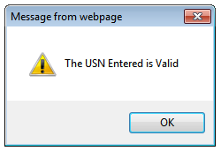

6. Develop and demonstrate, using JavaScript, a XHTML document that contains three short paragraphs of text, stacked on top of each other, with only enough of each showing so that the mouse cursor can be placed over some part of them. When the cursor is placed over the exposed part of any paragraph, it should rise to the top to become completely visible.
Description :

Objective to get acquainted with stack programming by mouse action and how to use stack programming in JavaScript code Stack programming can be done using dynamic programming.

Dynamic HTML

Much of what is called Dynamic HTML revolves around JavaScript. Dynamic HTML, or DHTML is a collection of tricks and tools that involve using scripting languages such as JavaScript to modify the content of Web pages and otherwise interact with the user. In its strictest sense, it is any code that allows you to change the content or appearance of a document in a Web browser. So, the first thing with JavaScript is change the content of a document being displayed in the Web browser. JavaScript does not change the document itself. If you refresh the browser it will go back to the original setting.
Rather, it will modify what is being displayed. For instance, JavaScript allows you to dynamically change the appearance of something when you move the mouse over it. Which can be done with this paragraph . It can even make elements appear and disappear from a document

Proceedure :-
1. Create an XHTML file.
2. Take an internal css file . The style type should be set to “"text/css"” . where the font, size, colors etc. are specified using layers.
3. Declare the script tag as text/javascript in the beginning of the <body> of xhtml program
4. Take paragraph in specified layers.
5. Assign index values to layers to decide the sequence so that the layer will come on the top which is selected by mouse.
6. Use function to get value by mouse action
_____________________________________________________________________________
<?xml version="1.0" encoding="utf-8"?>
<!DOCTYPE html PUBLIC="-/W3C//DTD XHTML 1.1//EN"
http://www.w3.org/TR/xhtml 1.1/DTD/xhtml11.dtd>
<html xmlns="http://www.w3.org/1999</xhtml">
<head>
<title>the stacking order</title>
<style type="text/css">
.layer1style
{
border: solid thick black; padding:1em; width:300px; background-color:green; position:absolute; top:100px; left:200px; z-index:0;
}
.layer2style
{
border:solid thick red; padding:1em; width:300px; background-color:blue; position:absolute; top:120px; left:220px; z-index:0;
}
.layer3style
{
border: solid thick green; padding:1em; width:300px; background-color:purple; position:absolute; top:140px; left:240px; z-index:0;
}
</style>
<script type ="text/javascript"> var toplayer = "layer3";
function mover(totop)
{
var oldtop = document.getElementById(toplayer).style;
var newtop = document.getElementById(totop).style; oldtop.zIndex ="0";
newtop.zIndex="10"; toplayer=document.getElementById(totop).id;
}
</script>
</head>
<body style="background-color:yellow">
<h2 style="text-align:center;color:red">pgm includes XHTML documnt 2 show the stacking of paragraph</h2>
<div style="z-index:10;" class="layer1style" id ="layer1" onmouseover="mover('layer1')" > MALNAD COLLEGE OF ENGINEERING </div>
<div style="z-index:2;" class="layer2style" id ="layer2" onmouseover="mover('layer2')" >
DEPT OF COMPUTER SCIENCE AND ENGINEERING </div>
<div style="z-index:3;" class="layer3style" id ="layer3" onmouseover="mover('layer3')">
WEB PROGRAMMING LAB</div>
</body>
</html>
___________________________________________________________________________

OUTPUT:
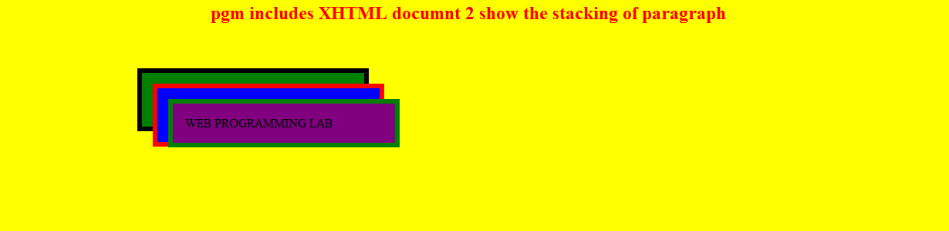

7. Write an XML file which displays the book details that includes the following:
- Title of book
- Author name
- Edition
- Price
Write a DTD to validate the above XML file and display the details in a table (to do this use XSL).

Display the XML file as follows:
The contents should be displayed in a table. The header of the table should be in color GREY and the Author names column should be displayed in one color and should be capitalized and in bold. Use your own colors for remaining columns. Use XML schemas XSL and CSS for the above purpose.

AIM: To write an XML file that displays book information.
DESCRIPTION: XML stands for EXtensible Markup Language. XML is a markup language much like HTM and was designed to carry data, not to display data. XML tags are not predefined. You must define your own tags. XML with correct syntax is "Well Formed" XML. The purpose of a DTD is to define the structure of an XML document. It defines the structure with a list of legal elements. XML validated against a DTD is "Valid" XML. With XSLT you can transform an XML document into HTML, before it is displayed by a browser

PROGRAM:
book.xml:
<?xml version="1.0" ?>
<?xml-stylesheet href="book.xsl" type="text/xsl" ?>
<!DOCTYPE catalog SYSTEM "book.dtd">
<catalog xmlns:xs="http://www.w3.org/2001/XMLSchema-instance"
xs:noNamespaceSchemaLocation="book.xsd">
<bookdetails>
<title>XML bible</title>
<author>watson</author>
<edition>5</edition>
<price>50</price>
</bookdetails>
<bookdetails>
<title>HTML Bible</title>
<author>chris bates</author>
<edition>5</edition>
<price>39</price>
</bookdetails>
<bookdetails>
<title>Beginning Web Programming</title>
<author>john duckett</author>
<edition>4</edition>
<price>49</price>
</bookdetails>
<bookdetails>
<title>Java Server Pages</title>
<author>hans bergsten</author>
<edition>3</edition>
<price>39</price>
</bookdetails>
<bookdetails>
<title>Programming World Wide Web</title>
<author>sebesta</author>
<edition>6</edition>
<price>45</price>
</bookdetails>
</catalog>
book.dtd
<!ELEMENT catalog (bookdetails+)>
<!ELEMENT bookdetails (title,author,edition,price)>
<!ELEMENT title (#PCDATA)>
<!ELEMENT author (#PCDATA)>
<!ELEMENT edition (#PCDATA)>
<!ELEMENT price (#PCDATA)>

book.xsd
<?xml version="1.0" ?>
<xs:schema xmlns:xs="http://www.w3.org/2001/XMLSchema">
<xs:element name="catalog">
<xs:complexType>
<xs:sequence>
<xs:element name="bookdetails" maxOccurs="unbounded">
<xs:complexType>
<xs:sequence>
<xs:element name="title" type="xs:string" />
<xs:element name="author" type="xs:string" />
<xs:element name="edition" type="xs:integer" />
<xs:element name="price" type="xs:float" />
</xs:sequence>
</xs:complexType>
</xs:element>
</xs:sequence>
</xs:complexType>
</xs:element>
</xs:schema>

book.xsl

<xsl:stylesheet version="1.0" xmlns:xsl="http://www.w3.org/1999/XSL/Transform" >
<xsl:template match="/">
<html>
<body>
<table border="2" bordercolor="black" cellspacing="0" align="center" style="fontfamily:calibri;text-align:center">
<caption><h2 style="color:blue;text-decoration:underline">BOOK
DETAILS</h2></caption>
<tr style="background-color:gray;text-transform:uppercase;">
<th>title</th>
<th>author</th>
<th>edition</th>
<th>price</th>
</tr>
<xsl:for-each select="catalog/bookdetails">
<tr>
<td style="background-color:orange;"><xsl:value-of select="title" /></td>
<td style="background-color:cyan;text-transform:capitalize; font-weight:bold">
<xsl:value-of select="author" /></td>

<td style="background-color:yellow;"><xsl:value-of select="edition" /></td>
<td style="background-color:green;"><xsl:value-of select="price" /></td>
</tr>
</xsl:for-each>
</table>
</body>
</html>
</xsl:template>
</xsl:stylesheet>
______________________________________________________________________________
OUTPUT:
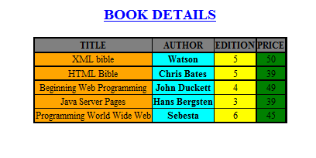

8. Write a PHP program to store current date-time in a COOKIE and display the Last visited on date-time on the web page upon reopening of the same page.

Basics:
PHP, or PHP: Hypertext Preprocessor, is a widely used, general-purpose scripting language that was originally designed for web development, to produce dynamic web pages. It can be embedded into HTML and generally runs on a web server, which needs to be configured to process PHP code and create web page content from it. It can be deployed on most web servers and on almost every operating system and platform.
PHP primarily acts as a filter, taking input from a file or stream containing text and/or PHP instructions and outputs another stream of data; most commonly the output will be HTML. Since PHP 4, the PHP parser compiles input to produce
_____________________________________________________________________
<?php
//Calculate 60 days in the future
//seconds * minutes * hours * days + current time
$inTwoMonths = 60 * 60 * 24 * 60 + time();
setcookie('lastVisit', date("G:i - m/d/y"), $inTwoMonths);
if(isset($_COOKIE['lastVisit']))
{
$visit = $_COOKIE['lastVisit'];
echo "Your last visit was - ". $visit;
}
else
echo "You've got some stale cookies!";
?>
___________________________________________________________________________
OUTPUT:

Your last visit was -12:23 - 11/12/2015

